***“The most important non-linear data structure in computer science.”***

***- David Knuth, The Art of Computer Programming, Vol. 1***

* **Treeshorizontal line**
  + *Rooted* : every node can be reached via a path from the root
  + *Acyclic* : without cycles
  + Vertex: “nodes”
  + Edge: a connection between two vertices
  + Path: sequence of edges
  + Parents: Node **b, d, x** have Node **a** as their parent
  + Children: **b, d, x,** are the children of **a**
  + Siblings: **b, d, x,** are siblings of each other
  + Ancestors: **u** has ancestors **l, d, a**
  + Descendants: **x** has **s, m** as its descendants
  + Leaves: Vertices with no children

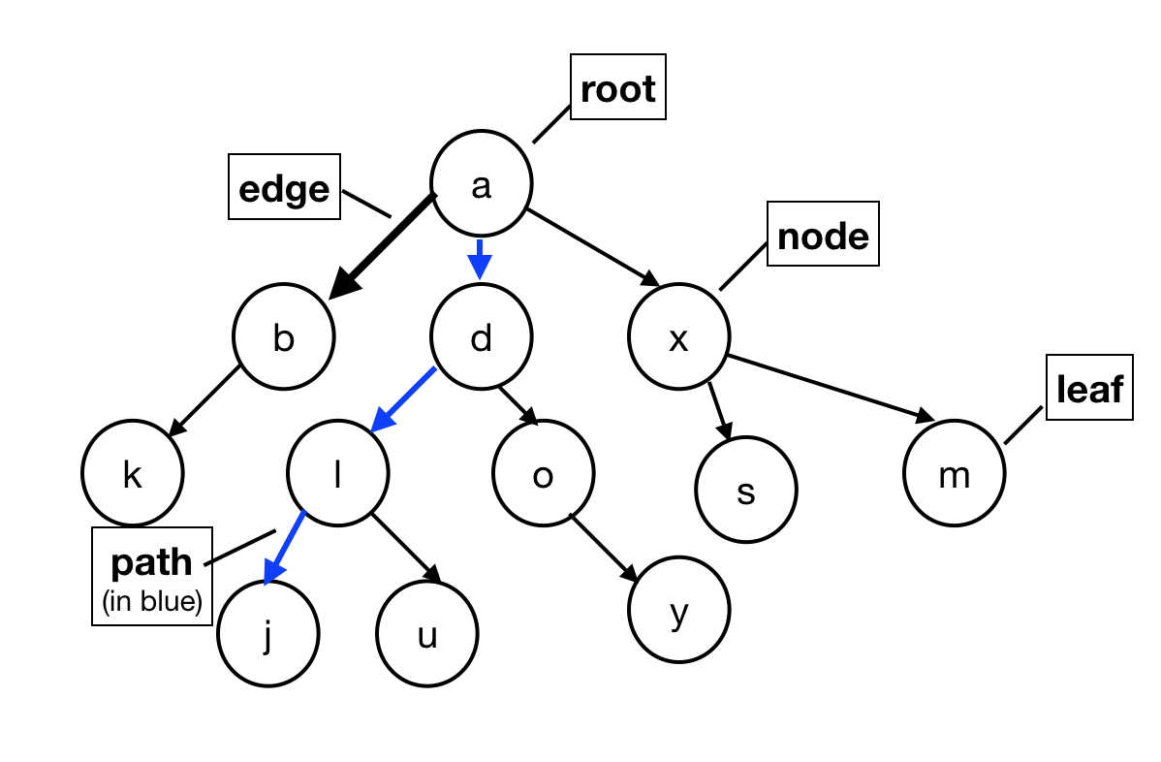

* **Binary Trees**
  + Each node has *at most two children*: left child and right child
  + Each node has a left and a right subtree (can be empty)

